AI ASSISTED CODING
LAB-13.2
ROLL NO-2403A52082
BATCH-04
TASK-1:
PROMPT:Generate the following Python function to remove repetition and improve modularity. Use either dictionary-based dispatch or separate functions for each shape. The goal is cleaner, more maintainable code.
CODE:
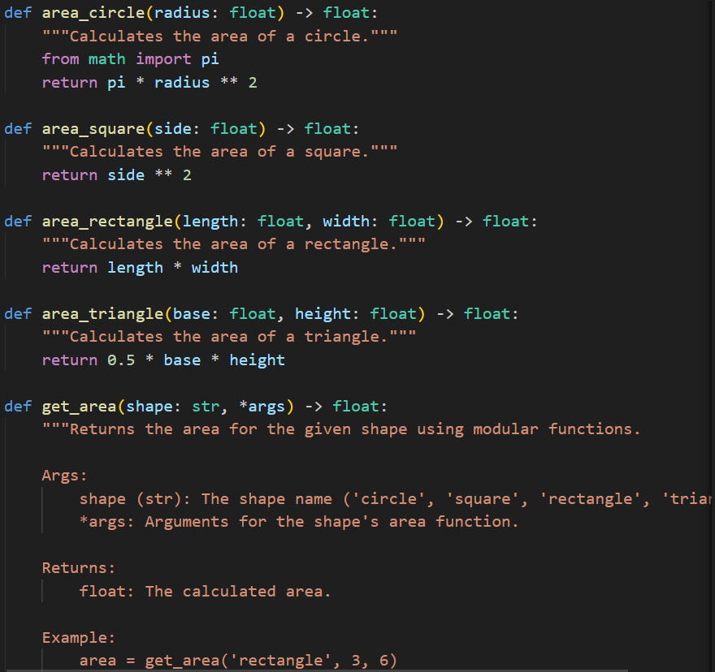
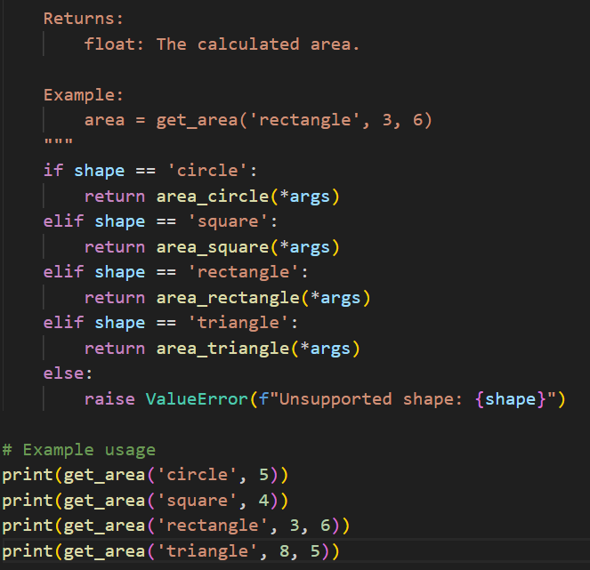

OUTPUT:
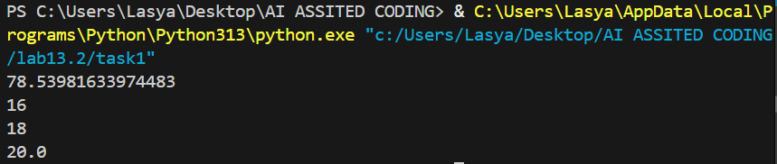
- OBSERVATION: The code uses separate functions for each shape, improving modularity and readability.The get_area function dispatches to the correct shape function based on the input, reducing repetition.Error handling is included for unsupported shapes.Example usage demonstrates how to calculate areas for different shapes.The code is clean, maintainable, and follows good Python practices.
TASK-3:
PROMPT: GENERATE A PYTHON CODE THAT WORKS ON READABILITY AND MODULATARY FUNCTIONS ON THE BELOW CODEclass Student:
def init(self, n, a, m1, m2, m3):
self.n = n
self.a = a
self.m1 = m1
self.m2 = m2
self.m3 = m3
def details(self):
print("Name:", self.n, "Age:", self.a)
def total(self):
return self.m1+self.m2+self.m3
CODE:
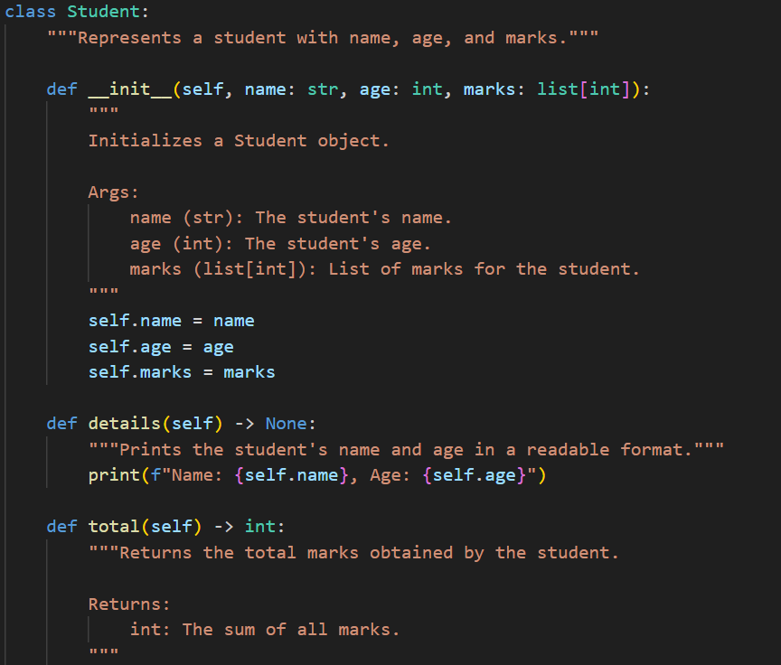
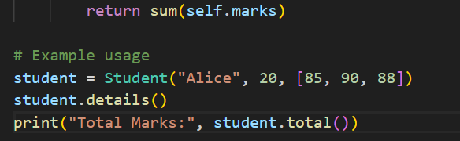
OUTPUT:
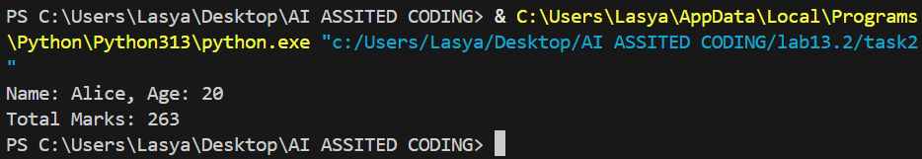
- OBSERVATION: The code is modular and readable.Student info and marks are clearly managed.Docstrings improve documentation.Example shows usage and output.
TASK-4:
PROMPT: Refactor this Python loop using a list comprehension for better performance and readability.
CODE:
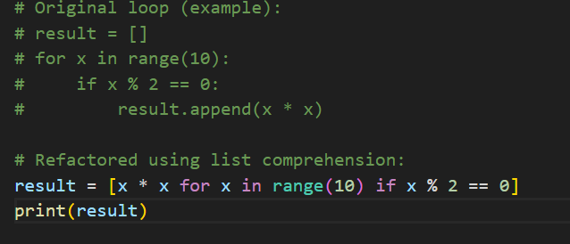
OUTPUT:
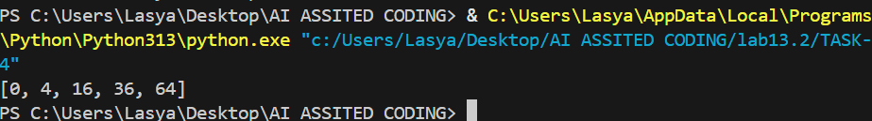
- OBSERVATION: The code replaces a traditional loop with a list comprehension, improving readability and conciseness.It efficiently generates a list of squares of even numbers from 0 to 9.The output is [0, 4, 16, 36, 64].List comprehensions are generally faster and more Pythonic for such tasks.
TASK-2:
PROMPT: Refactor the legacy Python function to include proper error handling and resource management. Replace manual file operations with a with open() block and wrap the logic in a try-except structure to handle file-related exceptions gracefully.
CODE: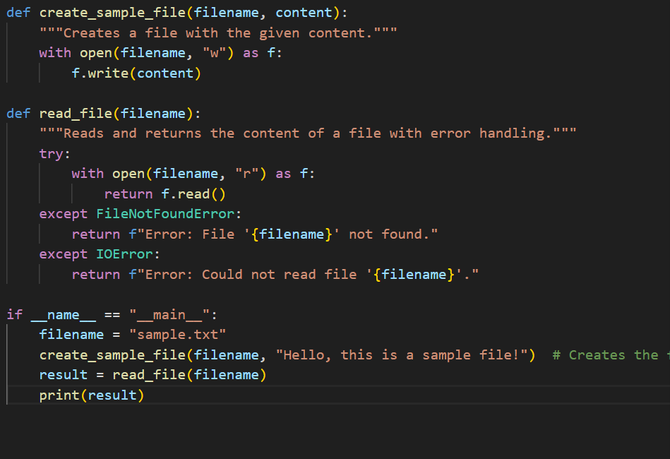
OUTPUT:
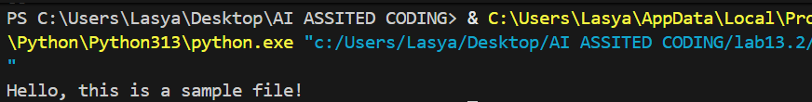
OBSERVATION: The program successfully creates a sample file and reads its content. It uses exception handling to manage missing files or read errors, providing user-friendly error messages. The output displays the file content, confirming that both file creation and reading work as intended.

